Step by Step Guide:

Mock Collaborative Project Portfolio.

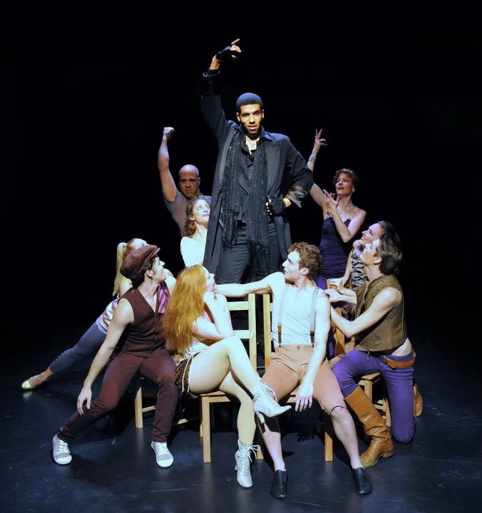

This document will guide you through the process of creating your Collaborative Project Portfolio, referring to specific examples you have covered during your creative journey.

What should I include in my Collaborative Project Portfolio?

The portfolio should clearly evidence your creative process throughout your engagement with the Collaborative Project:

- Preparation

- Action

- Reflection

The portfolio can contain a variety of material in different formats (such as text, visuals, diagrams and so on) depending on the nature of the project.

How long should it be and how should it be presented?

The portfolio may be up to 15 pages in length and can contain a variety of materials in different formats. For example:

- Mind Maps
- Storyboards
- Photographs
- Annotated Images
- Diagrams
- Tables

It can be handwritten or typed (or a mixture of both) but ensure that it is legible.

The portfolio should contain a table of contents (which is excluded from the page count) and all pages should be numbered.

The main body of the portfolio should be structured using the following subheadings:

- A. My personal context and my research into a professional company that creates and stages original theatre.

- B. The formation of my group and our exploration of the starting point (including our target audience and intentions for the piece).

- C. Reflections of the collaborative development of our piece and the specific explorations led by me.

- D. My contribution to the final 13- 15 minute presentation, the impact on the audience and my artistic choices (as seen in the video).

What should be addressed in each section?

A. My personal context and my research into a professional company that creates and stages theatre.

Personal Context
In this section you will detail the creative skills set that YOU can offer your ensemble.

- What are your strengths within the creative process?

- What inspires you as an artist?

- Has there been a particular workshop or live theatre experience that has stuck with you and inspired your creative decisions within DP Theatre?

- What are your personal strengths and how could they benefit your ensemble?

- How can this personal context (your strengths, interests and passions) contribute to development of this collaborative process?

Don’t just refer to your skills as a performer. What about directing skills, design skills etc…?

Research into a Professional Theatre Company
You must also evidence the theoretical and practical exploration of your chosen Professional Theatre Company (Frantic Assembly) and explain how this company influences your own ensemble’s creative process.

- What prompted you to explore Frantic Assembly? What interests you about their work?

- Referring to specific research findings, define what makes Frantic Assembly unique. What separates them from other theatre companies?

- Can you make any connections between other styles/practitioners that you have studied during DP Theatre?

- How can Frantic’s ideas influence your collaborative project? For example:

- Style of Collaboration?
- Production Elements?
- Pre Show?
- Movement Style?
- Universal themes?

B. The formation of the group and exploration of the starting point (including our target audience and intentions for the piece).

The Formation of the Group
For this mock collaborative project, I dictated that you work together as a six, so this section will be a little challenging. Nonetheless, please try and fulfill the requirements of this part of the assessment.
You should introduce your group and explain what skills, interests, and experience they bring to the ensemble.
- Explain why you have chosen to work together as an ensemble.

- How do each of your individual strengths and interests work together and complement each other to create an effective ensemble?

Exploration of the Starting Point

You must introduce the initial starting point you selected as a group and clearly justify your decision.
- What interested you about the image that you chose?

- How did it act as a catalyst for your creative process? What creative journey did it inspire?

- Explain in minute detail how your ensemble explored the starting point. Evidence the development of your ideas stemming from the initial engagement with your chosen starting point to the outline of your performance concept (artistic intention). Reference both theoretical and practical exploration and research during this section.

Intentions and Target Audience
The culmination of this section (the exploration of the starting point) should be the introduction of your ensemble’s artistic intention.
- What is the intended message of your piece?

- What theme/ideas do you wish to address?

- How will you address them? Theatre style? Frantic influence etc.?

- Who is your target audience? Justify this choice in connection to the message and the theme/s you wish to address within your piece.

C. Reflections of the collaborative development of our piece and the specific explorations led by me,
Reflection of the collaborative development of our piece
During this section you should record the development of your collaborative project, referencing specific moments during the rehearsal process.
Be consistently reflective throughout. Do not interpret reflection as a ‘stand alone’ section. You should continually critique and analyze the rehearsal process and the development of the project, with reference to your artistic intention outlined in the previous section.

- What was the aim/s of a specific rehearsal? Explain what your ensemble wanted to achieve, with reference to your artistic intention.

- What specific skills/techniques were used within rehearsals and why?

- How did the rehearsal develop your project further? (Create an effective ensemble? Develop a performance? Apply Frantic techniques? Apply practitioner ideas?)

Specific Exploration Led by Me
It is important that you explain your own contribution to the project. You could refer to:

- A workshop you led to explore Frantic Assembly
- A workshop you led to explore a specific practitioner
- A workshop you led to explore a theme/concept
- A scene that you devised for the performance

Explain why you led this exploration; you could link this justification to your personal context. Perhaps it links to a particular interest or strength you have?
You should consistently be reflective throughout. Do not interpret reflection as a ‘stand alone” section, separate from the description of the content of your rehearsal. You should continually critique and analyze the rehearsal process and the development of the project, with reference to your artistic intention outlined in the previous section.

- What was the aim/s of a specific rehearsal? Explain what you wanted to achieve during your rehearsal/workshop, with reference to your artistic intention.

- What specific skills/techniques were used within rehearsals and why?

- How did the rest of your ensemble respond to your workshop? Were they receptive to your ideas/exercises/direction? Did they respond how you anticipated?

- How did the rehearsal develop your project further? (Create an effective ensemble? Develop a performance? Apply Frantic techniques? Apply practitioner ideas?)

D. My contribution to the final 13- 15 minute presentation, the impact on the audience and my artistic choices (as seen in the video)

The last section of your portfolio focuses solely on your ensemble’s final performance and the impact it had on the audience.
You must provide a clear and detailed evaluation of final performance and your role within it. Within this evaluation, you must consider your audience’s response to your project.

Contribution and Artistic Choices within the Final Performance
Describe the role/character you played within your collaborative project, and explain what specific skills and techniques you utilized to communicate this role effectively to the audience.
- Analyze whether you communicated your role effectively to the audience.

- You made artistic choices to perform your role using selected skills and techniques. Evaluate whether these choices were effective and if they achieved the desired performance outcome.

- What were the strengths of your performance and what areas could have been developed further?

- How did your contribution to the performance enable your ensemble to achieve your artistic intention?

You can make reference to chosen edited moments from the video of your performance during this section.

Evaluation of Final Performance and Impact on the Audience

Within this section you must clearly evaluate whether your piece fulfilled its intentions, with reference to the artistic intention that you outlined in a previous section of your portfolio.

- Ensure that you justify your reasons for stating whether or not your performance fulfilled its intentions, detailing clear examples of specific moments from your piece.

- Restate your intended impact on the audience (this should have been explained in a previous section of your portfolio) and evaluate whether or not your performance affected the audience in the way that your ensemble had anticipated.

- During your evaluation you must refer, in detail, to specific feedback given to you from your audience. You should have gathered this feedback straight after your performance. You cannot gain top band marks if you do not refer to this feedback session.

Assessment Criteria

A. Theatre in context: The personal context and research into a professional company.
- To what extent does the student present their own personal context and outline their own approaches, interests and skills in theatre?

- To what extent does the student present their research into the approaches used by a professional company that creates and stages original pieces of theatre?

Mark | Descriptor
0 | The work does not reach a standard described by the descriptors
1-2 | The work is inconsistent:  - the student lists their own personal approaches, interests and skills in theatre  - the student lists the creative approaches employed by an appropriate professional company that creates and stages original pieces of theatre, with little consideration of how this research may influence their approach to collaborative theatre making.
3-4 | The work is underdeveloped:  - the student outlines their own personal approaches, interests and skills in theatre  - the student outlines the creative approaches employed by an appropriate professional company that creates and stages original pieces of theatre, with some consideration of how this research may influence their approach to collaborative theatre making.
5-6 | The work is good  - the student describes their own personal approaches, interests and skills in theatre  - the student describes the creative approaches employed by an appropriate professional company that creates and stages original pieces of theatre, with consideration of how this research may influence their approach to collaborative theatre making.
7-8 | The work is excellent:  - The student explains their own personal approaches, interests and skills in theatre  - The student explains the creative approaches employed by an appropriate professional company that creates and stages original pieces of theatre, clearly and fully considering how this may influence their approach to collaborative theatre making.

B. Theatre in context: The formation of the group and exploration of the starting point (including target audience and intentions for the piece)

- To what extent does the student reflect on the process involved in forming the collaborative group?

- To what extent does the student explain how the group went about exploring the starting point, which includes identifying the target audience and intentions for the group?

Mark | Descriptor
0 | The work does not reach a standard described by the descriptors
1-2 | The work is inconsistent:  - the student lists milestones in forming the collaborative group, showing little or no awareness of the challenges and benefits of collaboration  - the student lists milestones in the collaborative exploration of the starting point, with little consideration of how the target audience or artistic intentions were identified.
3-4 | The work is underdeveloped:  - the student outlines the process of forming the collaborative group, showing some awareness of the challenges and benefits of collaboration  - the student outlines how and why the ensemble collaboratively explored the starting point, with some consideration of how the target audience and artistic intentions were identified.
5-6 | The work is good  - the student describes the process of forming the collaborative group, reflecting on the challenges and benefits of collaboration  - the student describes how and why the ensemble collaboratively explored the starting point, with consideration of how the target audience and artistic intentions were identified.
7-8 | The work is excellent:  - the student explains the process of forming the collaborative group, clearly and effectively reflecting on the challenges and benefits of collaboration  - the student explains how and why the ensemble collaboratively explored the starting point, with clear consideration of how the target audience and artistic intentions were identified.

C. Theatre processes: Reflections on the development of the piece and the specific explorations led by the student

- To what extent does the student reflect on the collaborative process employed to develop, structure and prepare the original theatre piece for presentation?

- To what extent does the student reflect on the specific explorations they led with the group, and the contribution this made to the shaping of the production?

Mark | Descriptor
0 | The work does not reach a standard described by the descriptors
1-2 | The work is inconsistent:  - the student lists key milestones in how the group practically developed, structured and prepared the original piece for presentation, with little identification of their contribution to this process  - the student lists the specific artistic explorations they led with the group.
3-4 | The work is underdeveloped:  - the student outlines how the group practically developed, structured and prepared the original piece for presentation, with some identification of their contribution to this process  - the student outlines the specific artistic explorations they led with the group and state how this contribution helped shape the final production.
5-6 | The work is good:  - the student describes how the group practically developed, structured and prepared the original piece for presentation, identifying their own contribution to this process  - the student describes the specific artistic explorations they led with the group and reflect on how this contribution helped shape the final production.
7-8 | The work is excellent:  - the student clearly explains how the group practically developed, structured and prepared the original piece for presentation, clearly identifying their own contribution to this process  - the student provides insightful reflection on the specific artistic explorations they led with the group and explain how this contribution helped shape the final production.

D. Presenting theatre: Evaluation of the student’s contribution to the final 13-15 minute performance and their artistic choices (as seen in the video)
- To what extent does the student evaluate the presentation of the original 13-15 minute theatre piece, the extent to which the piece fulfilled its intentions and the impact it had on the audience?

- To what extent does the student analyse and justify their artistic choices (as evidenced in the selected video recording)?

Mark | Descriptor
0 | The work does not reach a standard described by the descriptors
1-2 | The work is inconsistent:  - the student attempts to evaluate the presentation of the original piece, listing ways in which the piece fulfilled its intentions and the extent to which it achieved its impact on the audience, but this is superficial or inconsistent.  - The student lists the ways in which their own specific artistic choices were made as evidenced in the selected video recording.
3-4 | The work is underdeveloped:  - The student provides a clear evaluation of the presentation of the original piece, outlining how the piece fulfilled its intentions and the extent to which it achieved its impact on the audience  - the student outlines their own specific artistic choices as evidenced in the selected video recording
5-6 | The work is good:  - the student provides a clear and effective evaluation of the presentation of the original piece, describing how the piece fulfilled its intentions and the extent to which it achieved its impact on the audience  - the student describes their own specific artistic choices as evidence in the selected video recording.
7-8 | The work is excellent:  - the student provides a clear, effective and sophisticated evaluation of the presentation of the original piece, explaining how the piece fulfilled its intentions and the extent to which it achieved its impact on the audience  - the student explains their own specific artistic choices as evidenced in the selected video recording.

LIST? OUTINE? DESCRIBE? EXPLAIN? Created by Emily MORAN
What’s the Difference??? Here are the IB definitions:

List Give a sequence of brief answers with no explanation.

Outline Give a brief account or summary.

Describe Give a detailed account.

Explain Give a detailed account including reasons or causes.

