The Director’s Notebook : The Ultimate Guide
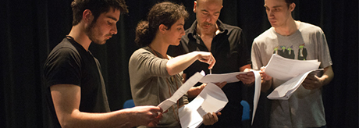
What you actually do and don’t do:
You independently choose a published play text, read the text and record your personal responses. You then:
- research and record the cultural and/or theoretical context of the play and identify ideas the playwright may be addressing
- explore the play and record your own ideas about how this play may be staged for an audience
- explain your directorial intention(s) and explain how this will inform your staging of two particular moments of the play; these can be moments of atmosphere, emotion or tension or which communicate the meaning(s) of the play; you must demonstrate an understanding of how performance and production elements function together to create these moments
- make reference to live performances they have experienced and how these have influenced, inspired or informed their directing of these moments. The live theatre performances must not be a production of the same play you have chosen this assessment task.
This process could be first recorded in your journal, then curated and presented in the form of a director’s notebook (20 pages maximum), which is made up of visuals and words.
This is a theoretical exercise. The play text is NOT actually staged as part of the assessment task though you may choose to work practically as part of the process of exploring the play or examining particular moments. You are NOT permitted to edit, make additions or alterations to the play text selected for study. All sources must be acknowledged and cited.
You approach this task from the perspective of a director.

The aim of this task is for you to explore the processes involved in transforming a play text into live action by developing a directorial vision for staging the play text.
What you will learn from the process:
Through this exploration you will understand:
- the importance of research into the context of a play text and how this can inform your directorial intentions for staging the play text
- the artistic processes required to transform text into action
- how meaning is communicated on stage and how to create moments of atmosphere, emotion and tension
- how performance and production elements function together to create an intended impact for an audience
- how live performances you have seen and experienced influence, inspire and inform your work as a director.
THE DIFFERENCE BETWEEN THE ROLE AND THE TASK
This task is concerned with the textual exploration a director might carry out before they go into the rehearsal room to work with actors, defining what they want to bring out of the text and how it might look when finally staged. The process of how this might be achieved through rehearsals is NOT the focus of this task.
It is unlikely that a director would be responsible for the full scenic or technical design of the final theatre production; however their vision for the staging of the play text would certainly involve a clear understanding of how individual production elements might be employed to fulfill their directorial intentions and how these would potentially impact on the audience
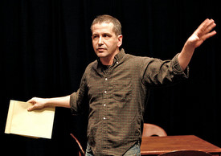

How it links to your learning on the course:
THEATRE IN CONTEXT | THEATRE PROCESSES | PRESENTING THEATRE
Researching and examining the various contexts of at least one published play text and reflecting on live theatre moments they have experienced as spectators. | Taking part in the practical exploration of at least two contrasting published play texts and engaging with the process of transforming a play text into action. | Directing at least one scene or section from one published play text which is presented to others.
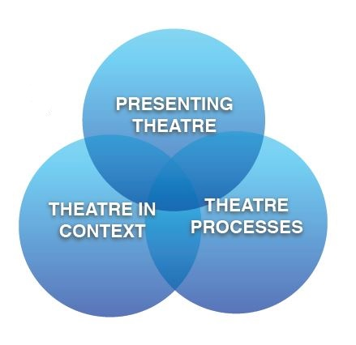
How the process links to your learning:
Theatre in Context
- You will carry out research into the cultural context from which the play originates and/or research into the play text’s theoretical context, focusing on its style, form, practice or genre.
- You will identify the key ideas presented by the playwright (such as intended meanings, motifs, themes or through-line). As the author(s) of the text, the playwright might be one person, more than one person or in some cases a theatre company.
- You document both of these processes in your theatre journal.
Theatre Processes
- You record your interpretation of your chosen play text and your artistic responses to the entire play text as a director, making links to live theatre performances you have experienced as a spectator that have influenced, inspired or informed you. REMEMBER, the live theatre performances must not be productions of the same play you have chosen for this assessment task.
- You record your exploration of your chosen play and your own ideas about how this play may be staged for an audience.
- You document both of these processes in your theatre journal.
Presenting Theatre
- You explain your directorial intention(s) and your intended impact on audience and demonstrate/record how this would inform your staging of two particular moments of the play. These can be moments of atmosphere, emotion or tension or moments that communicate the meaning(s) of the play.
- You demonstrate you’re understanding, through the staging of these two moments, of how performance and production elements function together.
- You document both of these processes in your theatre journal.
Discussing live theatre performance in your Director’s Notebook
In you final Director’s Notebook, you must discuss and make links to live theatre performances you have experienced as a spectator during the theatre course. You should identify performances that have influenced, inspired or informed you and should pay particular attention to how directors employed production and performance elements to create effective moments of atmosphere, emotion or tension or moments that communicated meaning in the live theatre performance experienced.
The live theatre performances identified must not be productions of the same play text selected for study in this assessment task. Neither are you allowed to write about productions in which you have had involvement, for example school plays in which you helped backstage or local productions in which you have performed.
How you choose and use your play:
You choose a published play text that you have not previously studied (or acted in), which you are interested in practically exploring as a director and which would allow you to successfully fulfill the assessment requirements and criteria of the task.
CHOOSING YOUR PLAY CAREFULLY
Your choice play text must be one you have not studied in class, and for which you can clearly identify the potential for success in transforming it from page to stage, so this choice is crucial and will be guided by your teacher. Once you have made your choice, the play cannot be used for any other assessment task for this course.
You need to, and you must, read a number of plays before you make your final choice, which you will do in discussion with your teacher. The key to success in this task is for you to choose a text that excites your imagination and that you will be passionate about transforming into action and putting on stage.
You cannot edit, make additions or alterations to the original printed work. You can, however, in communicating your vision for the staging of the selected play text, add as much additional action or introduce additional elements of design if this will help you to realise your vision for the staging. HOWEVER, in every case of an addition, it must be appropriate to the play text and you must clearly identify and justify these additions in your journal at first and then in your Director’s Notebook.
On the other hand, the play text does not necessarily have to be set within the original practice/style/genre for which it was originally intended. You can to set the play in a contrasting practice or style in order to bring out a particular idea or theme appropriate to your intention.
Also, you can work with play texts written in any language. However, any descriptions of plot or direct quotations used in your final Director’s Notebook must be translated into English.

Things to think about to get you going:
- What may have influenced the playwright, and what are his or her intentions?
- How do the theatre productions you have seen inform, influence or inspire his or her interpretations of a play and his or her work as a director?
- How have the cultural, social and/or political conditions of the time influenced or inspired the play?
- What is the genre/style of the play, and how has the playwright employed the art form to communicate his or her intentions and ideas? To what effect?
- What processes does a director employ to develop his or her intention and vision?
- What processes does a director employ to bring text to life?
- What processes are involved in staging a play text?
- How does a director present his or her ideas for staging moments of a play?
- How does a director communicate his or her interpretations and intentions in a directorial notebook?

What the Director’s Notebook should actually look like:
The Director’s Notebook must:
- Be up to 20 Pages long
- Be a combination of creative ideas, presented in words and visuals (photos, drawings, storyboards, mood boards etc)
- Be written in the first person
- Present your personal interpretations, responses, ideas, discoveries and intentions for the proposed staging of your chosen play.
- Be precise and specific as possible when discussing performance and production elements.
- Use subject specific terminology (that will help you being precise).
- Be clearly annotated and appropriately referenced to acknowledge all sources
- Also acknowledge and identify any of your own photographs or images in the same way
- Have a table of contents (that is excluded from the word count)
- Have numbered pages
- Have all sources cited in a separate document (see examples in Lionel)

Use of sources
As well as the more obvious sources (books, websites, videos, DVDs, articles) valid research should also include your own practical explorations of the play. You are also required to refer to theatre experiences you have had as a spectator. All sources consulted must be acknowledged following the referencing style used by Discovery College and be presented in a bibliography and as footnotes of the director’s notebook.
The structure of the Notebook:
  - The play text, its context and the ideas presented in the play
  - My artistic responses, creative ideas and explorations and my own experiences of live theatre as a spectator
  - My directorial intentions and the intended impact on an audience
  - How I would stage TWO moments of the play
WHAT THE IBO REQUIRES FROM YOU, IN THEIR WORDS
Each student submits for assessment:
- a director’s notebook (20 pages maximum) which includes: the student’s research into the published play text, its relevant contexts and the ideas presented in the play
- the student’s artistic responses and explorations of the entire play text as a director, referencing live performances they have experienced as a spectator that have influenced, inspired or informed them
- the student’s ideas regarding the staging of two specific moments from the play and how these would create the desired impact on an audience
- the student’s presentation of their final directorial intentions and the intended impact of these on an audience
- a list of all sources cited.

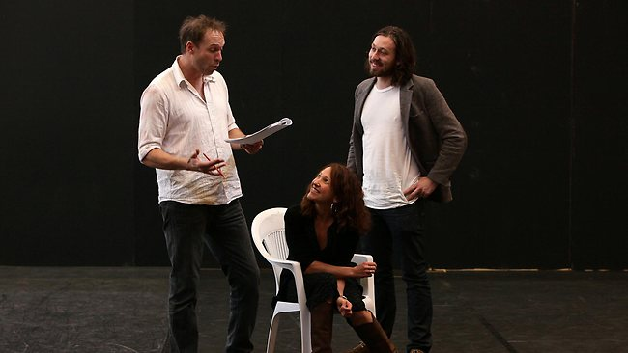
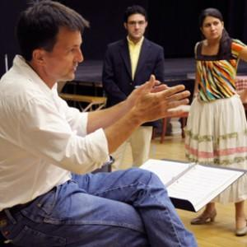
What it should actually look like:
Your actual Director’s Notebook is scanned, uploaded to the IBO and then assessed on screen so you need to make sure work is clear and legible when presented in a digital format. Therefore you MUST use an A4 format, landscape or portrait, with all pages numbered.

MARKING CRITERIA – THE DIRECTORS NOTEBOOK
 | 1 - 2 | 3 - 4 | 5 - 6 | 7 - 8
 | Inconsistent | Underdeveloped | Good | Excellent
Criteria A  Theatre in context: The play text, its context and the ideas  Presented | The student lists the cultural and/or theoretical context(s) of the play text using few appropriate sources, not always effectively.  The student identifies the ideas presented in the play text by the playwright but these are obvious or contrived and lack depth | The student outlines the cultural and/or theoretical context(s) of the play text using limited sources effectively  The student identifies some of the ideas presented by the playwright in the play text but does not identify appropriate links between these | The student describes the cultural and/or theoretical context(s) of the play text using a range of sources, but not always effectively  The student identifies the ideas presented in the play text and describes how these ideas are linked by the playwright. | The student explains the cultural and/or theoretical context(s) of the play text using a range of sources effectively  The student clearly identifies the ideas presented in the play text and explains how they are linked by the playwright.
Criteria B  Theatre processes: Artistic responses and live theatre experiences | The student lists any artistic responses, creative ideas or explorations of the play but these may be superficial or underdeveloped  The student makes little attempt to make links to their own experiences of live theatre and lists how directors employed production and performance elements to make impactful moments of live theatre. | The student outlines their artistic responses, creative ideas and explorations of the play but these may be lacking clarity  The student attempts to make links to their own experiences of live theatre and outlines how directors employed production and performance elements to make impactful moments of live theatre. | The student describes their artistic responses, creative ideas and explorations of the play with clarity and some imagination  The student makes some appropriate links to their own experiences of live theatre and describes how production and performance elements were combined to make impactful moments of theatre. | The student presents a clear, detailed and imaginative explanation of their artistic responses, creative ideas and explorations of the play  The student makes clear and appropriate links to their own experiences of live theatre and explains how directors employed production and performance elements to make impactful moments of live theatre.
Criteria C  Presenting theatre: The directors vision and intended impact | The student lists their directorial intentions but these may not be appropriate, effective or feasible  The student shows little consideration for how their staging of the play might create an intended impact on an audience. | The student outlines their directorial intentions which are largely appropriate, effective and feasible, but these may be underdeveloped  The student outlines how their staging of the play might create an intended impact on the audience. | The student describes their appropriate, effective and feasible directorial intentions which are supported by a range of ideas  The student describes how their staging of the play would create an intended impact on the audience. | The student clearly explains their appropriate, effective and feasible directorial intentions which are supported by a range of imaginative ideas  The student clearly explains how their staging of the play would create an intended impact on the audience.
Criteria D.  Presenting theatre: The staging of two moments of the play | The student lists how they would stage two moments of the play. This work is incomplete or contains edits, cuts or alterations to the original text  The student lists how production and performance elements would function together with little consideration of their stated intentions. | The student outlines how they would stage two moments of the play  The student outlines how production and performance elements would function together to fulfill their stated intentions. | The student describes how they would stage two moments of the play  The student describes how production and performance elements would function together to appropriately fulfill their stated intentions. | The student explains how they would stage two moments of the play  The student explains how production and performance elements would function together to appropriately and effectively fulfill their stated intentions.

